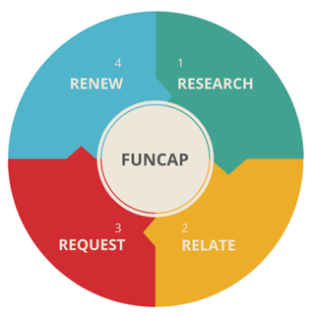
My FUNCAP
Action Plan

Phase 1 RESEARCH
How to develop a grant fundraising strategy and research our best potential donors

My biggest takeaway of this phase is:

WHAT | WHEN | WHO | STATUS
Action Step 1: |  |  | Done / Pending
Action Step 2: |  |  | Done / Pending
Action Step 3: |  |  | Done / Pending
Phase 2 RELATE
How to become visible and engage with donors

My biggest takeaway of this phase is:

WHAT | WHEN | WHO | STATUS
Action Step 1: |  |  | Done / Pending
Action Step 2: |  |  | Done / Pending
Action Step 3: |  |  | Done / Pending

Phase 3 REQUEST
How to write compelling grant proposals that ‘stick’ using storytelling elements

My biggest takeaway of this phase is:

WHAT | WHEN | WHO | STATUS
Action Step 1: |  |  | Done / Pending
Action Step 2: |  |  | Done / Pending
Action Step 3: |  |  | Done / Pending
Phase 4 RENEW
How to show your impact and renew your bond

My biggest takeaway of this phase is:

WHAT | WHEN | WHO | STATUS
Action Step 1: |  |  | Done / Pending
Action Step 2: |  |  | Done / Pending
Action Step 3: |  |  | Done / Pending

